NERVOUS SYSTEM: Action Potential Pre-lab Assignment:

http://highered.mcgraw-hill.com/sites/0072943696/student_view0/chapter8/animation__sodium-potassium_exchange_pump__quiz_1_.html

Visit the above animation site and follow these steps for each of the brief animations:
- View the animation
- Take the quiz
- Submit your results
- Copy the results and paste them into a word document as "unformatted text"
- Proceed to the next animation
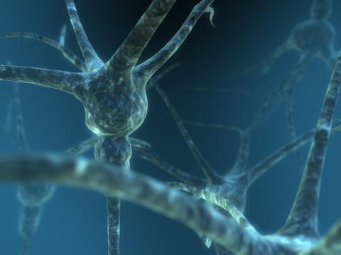
Print you results. (note: although animations repeat, the quizzes are different)
ANIMATION 1-3: SODIUM POTASSIUM PUMP
ANIMATION 4-5: CHEMICAL SYNAPSE
ANIMATION 6 : NERVE IMPULSE
ANIMATION 7 : TRANSMISSION ACROSS A SYNAPSE
ANIMATION 8-9: VOLTAGE GATED CHANNELS AND THE ACTION POTENTIAL
ANIMATION 10-11: ACTION POTENTIAL

